Student worksheet

6.1 The universe was studied by early Australians

Pages 140–141

Indigenous astronomers

1 What is a constellation?

|  |
| --- |
|  |
|  |

To the people living in the western desert, the emu constellation was part of their calendar. When the emu was running, it was time to hunt emus; and when the emu was sitting, it was time to collect emu eggs.

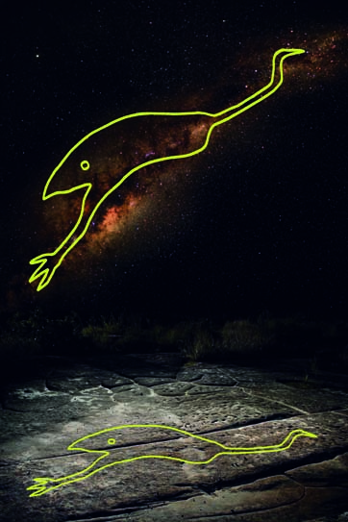

2 Why do you think the information above was important?

|  |
| --- |
|  |
|  |

3 In Australia today, most people recognise the group of stars that made up the emu as which galaxy?

|  |
| --- |
|  |

Extend your understanding

Australia's best-known constellation is the Southern Cross. Figure 1 shows how the Boorong people from north-western Victoria saw the Southern Cross. To them, it represented Bunya, who had run away from the evil emu Tchingal and hid in a tree for so long that he turned into a possum. Figure 2 shows that the Ngarrindjeri people who lived on the coast saw the stars of the Southern Cross as a stingray being chased by two sharks.

|  |  |
| --- | --- |
| L:\1. Publishing and Editorial\1. Product\Oxford Science\Oxford Science 10\3. Extras\6. Student worksheets\Artwork\4. Final jpgs\SW0602_01095.jpg | L:\1. Publishing and Editorial\1. Product\Oxford Science\Oxford Science 10\3. Extras\6. Student worksheets\Artwork\4. Final jpgs\SW0603_01095.jpg |
| Figure 1 | Figure 2 |

4 Why do you think that these two different groups of Aboriginal people had different stories for the Southern Cross? (Hint: Use a map to look at the regions where they lived.)

|  |
| --- |
|  |
|  |
|  |
|  |
|  |

Student worksheet

6.2 The Earth is in the Milky Way

Pages 142–143

Stellar magnitudes, parallax and distances

1 What are stars?

|  |
| --- |
|  |

2 Why is the apparent magnitude scale for the brightness of stars not suitable for comparing how much light a star is emitting compared with our own Sun?

|  |
| --- |
|  |
|  |
|  |
|  |

3 What does the colour of a star indicate?

|  |
| --- |
|  |
|  |
|  |

4 Our Sun has a surface temperature of about 5700 K and an absolute magnitude of 4.77. Use this information to indicate where our Sun would be positioned on the Hertzsprung–Russell diagram below.

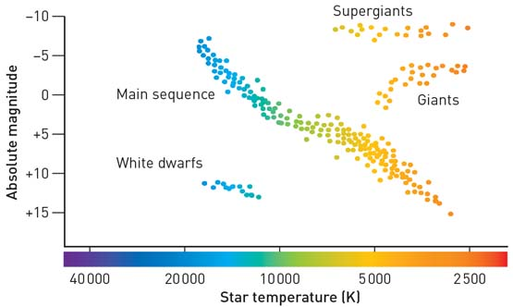

5 What type of star would have an absolute magnitude of –8.0 and a surface temperature of 3500 K?

|  |
| --- |
|  |
|  |

6 When are the best times to make parallax observations from Earth? Choose from one of the following and then explain your answer.

A Every 12 hours

B Every 24 hours

C Every 6 months

D Every 12 months

|  |
| --- |
|  |
|  |
|  |

The Sculptor Galaxy, also known as NGC 253, is a spiral galaxy that can be found in the constellation Sculptor. It has a diameter of 70 000 light-years and is at a distance of 11.4 million light-years.

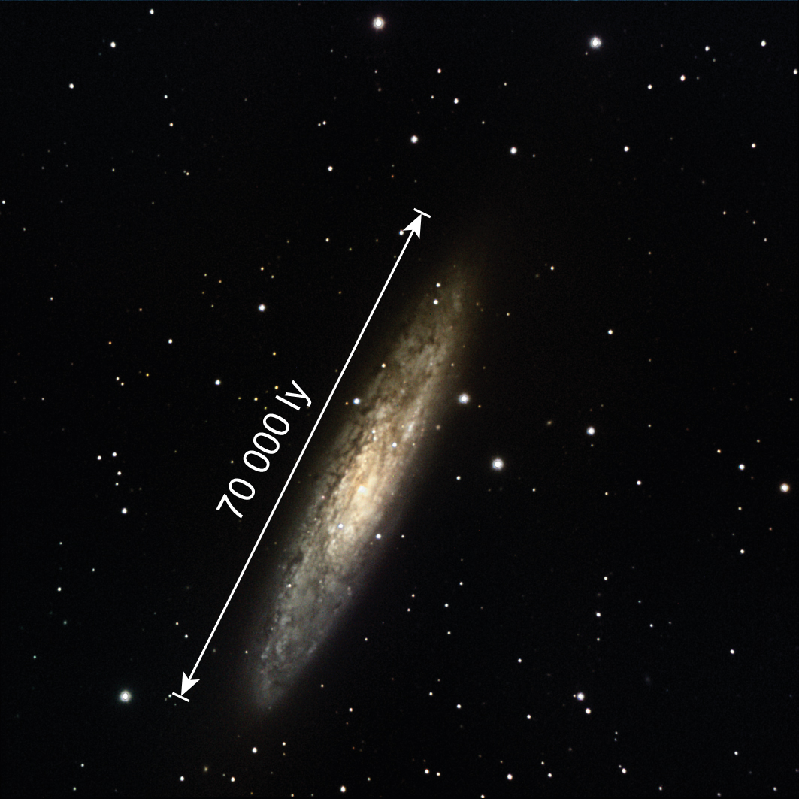

8 What does the term ‘light-year’ mean with respect to the size of the Sculptor Galaxy and how far it is from Earth?

|  |
| --- |
|  |
|  |
|  |

Extend your understanding

Another unit used to measure large distances in space is the parsec. A parsec (pc) is the distance at which a star, as shown in the diagram below, would have a parallax angle equal to one second (1ʺ) of arc.

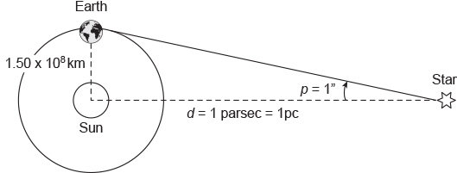

The absolute magnitude M of a star is defined as the apparent magnitude that it would have when viewed at a distance of 10 parsecs (10 pc) from Earth.

Remember that 1 parsec (1 pc) is the distance at which a star would have a parallax angle of one second of arc (1ʺ).

The basic formula that links a star's apparent (m) and absolute (M) magnitude with its distance (d) from Earth is:

$$M=m+5-5 \log_{10}(d)$$

where d is the distance to the star in parsecs (pc).

9 Sirius is the brightest star in the night sky. It has an apparent magnitude of –1.44 and is at a distance of 2.63 parsecs from Earth. Use the formula above and your calculator to work out its absolute magnitude.

|  |
| --- |
|  |

10 Our Sun has an apparent magnitude of –26.8 and is at a distance of 1.50 × 108 kilometres from Earth. Use the formula above and your calculator to show that its absolute magnitude is 4.77.

|  |
| --- |
|  |

11 At a distance of 10 parsecs, which star would appear brighter: our Sun or Sirius? Explain your answer.

|  |
| --- |
|  |
|  |
|  |

Student worksheet

6.3 Stars have a life cycle

Pages 144–145

Stellar evolution

1 Use the wordlist below to correctly identify each of the stages (A to F) in a star's life cycle if it initially has a mass greater than eight solar masses and a core mass greater than three solar masses. Write your answers in the table provided.

|  |  |  |  |  |
| --- | --- | --- | --- | --- |
| Supernova | Red super giant | Gas and dust | Main sequence | Neutron star |
| White dwarf | Protostar | Planetary nebula | Black hole | Super giant |

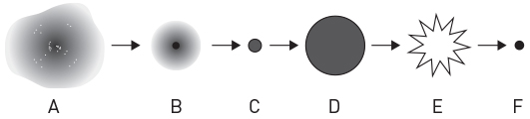

|  |  |
| --- | --- |
| A | D |
| B | E |
| C | F |

2 How is a neutron star formed?

|  |
| --- |
|  |
|  |
|  |

3 Describe the process that is occurring now in our Sun to produce its energy and maintain its stability.

|  |
| --- |
|  |
|  |
|  |

4 Explain what will happen inside, and what will happen to, the Sun when it reaches the end of the main sequence part of its life cycle.

|  |
| --- |
|  |
|  |
|  |
|  |
|  |

Extend your understanding

Astronomers have determined that the centre of our Milky Way galaxy is located in the constellation of Sagittarius, and have also hypothesised that there is a super massive black hole located there – dubbed Sagittarius A\*.

5 What evidence have astronomers been able to gather in support of the hypothesis that Sagittarius A\* is a super massive black hole? Use the internet to research the answer.

|  |
| --- |
|  |
|  |
|  |
|  |
|  |
|  |
|  |
|  |
|  |

Student worksheet

6.4 The galaxies are moving apart

Pages 146–147

Spectra, the Doppler effect and galactic motion

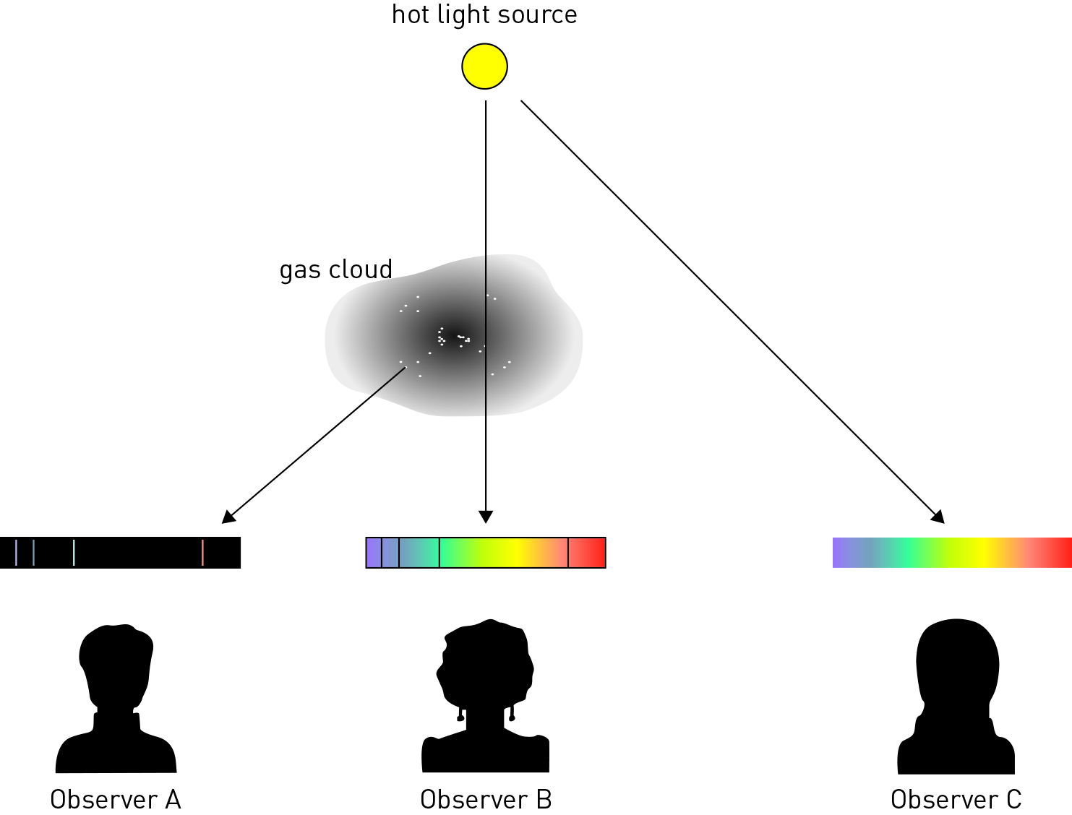

1 In the diagram above, which observer would see:

a a continuous spectrum?

|  |
| --- |
|  |

b an emission spectrum?

|  |
| --- |
|  |

c an absorption spectrum?

|  |
| --- |
|  |

|  |  |
| --- | --- |
| L:\1. Publishing and Editorial\1. Product\Oxford Science\Oxford Science 10\3. Extras\14. LSW\Artwork\Final jpgs\LSW0607_01095.jpg  Figure 1 | L:\1. Publishing and Editorial\1. Product\Oxford Science\Oxford Science 10\3. Extras\14. LSW\Artwork\Final jpgs\LSW0608_01095.jpg  Figure 2 |
| L:\1. Publishing and Editorial\1. Product\Oxford Science\Oxford Science 10\3. Extras\14. LSW\Artwork\Final jpgs\LSW0609_01095.jpg  Figure 3 | L:\1. Publishing and Editorial\1. Product\Oxford Science\Oxford Science 10\3. Extras\14. LSW\Artwork\Final jpgs\LSW0610_01095.jpg  Figure 4 |

2 Figure 1 shows a spectrum for hydrogen obtained in the laboratory. Which of Figures 2–4 best represents the hydrogen spectrum for a galaxy that is heading towards Earth? Explain your answer.

|  |
| --- |
|  |
|  |
|  |
|  |
|  |

3 What did Edwin Hubble discover about distant galaxies that helped provide evidence for the Big Bang theory?

|  |
| --- |
|  |
|  |
|  |

Extend your understanding

The Doppler Apparatus (shown below) can be used to understand how the Doppler effect works. To use it, you tie the apparatus to a rope and swing it around in circles. As the apparatus moves in circles, it produces a noise.

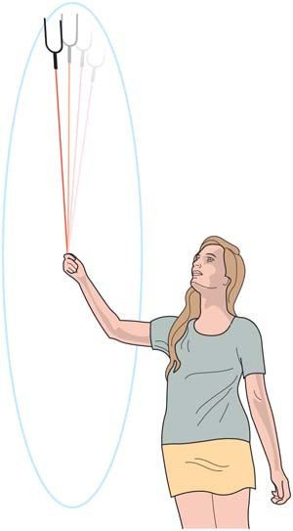

4 What would you expect to happen to the noise from the apparatus as it is swung around in a circle?

|  |
| --- |
|  |
|  |
|  |

5 Select an example of where else you may hear the Doppler effect in action. Describe how the effect would work in that situation.

|  |
| --- |
|  |
|  |
|  |
|  |

Student worksheet

6.5 The Big Bang theory is supported by evidence

Pages 148–149

Our expanding universe

1 What is the Big Bang theory?

|  |
| --- |
|  |

2 Why might the word ‘bang’ to describe the beginning of the universe be misleading?

|  |
| --- |
|  |
|  |

3 Use the table below to summarise the key evidence for the Big Bang theory.

|  |  |
| --- | --- |
| Aspect of Big Bang theory | Key evidence |
| Microwave background |  |
| Mixture of elements |  |
| The universe is changing |  |

4 Some scientists say that when we examine distant galaxies, we are looking back in time. What do they mean by this?

|  |
| --- |
|  |
|  |
|  |

Extend your understanding

|  |  |
| --- | --- |
| In 1925 American astronomer Edwin Hubble took a series of images of the nebula M31 (now popularly known as the Andromeda galaxy) and, on comparing them, discovered a Cepheid variable star that he called V1. He measured V1’s period of pulsation to be 31.4 days.  Since a Cepheid variable star’s period of pulsation determines its variation in magnitude, as discovered by American astronomer Henrietta Leavitt, Hubble was then able to calculate how far away V1 was from Earth. He did this by measuring V1’s variation in brightness and, on comparing this with the absolute variation predicted by the relationship discovered by Henrietta Leavitt, Hubble calculated that M31 was 285 000 parsecs away from Earth – this led to it being classified as a galaxy in its own right, and not part of our Milky Way galaxy. The universe had suddenly become a very large place!  In 1929 Hubble published a paper that showed the results of his investigation of the relationship between a galaxy’s radial velocity (derived from its Doppler shift) and its distance from Earth. | L:\1. Publishing and Editorial\1. Product\Oxford Science\Oxford Science 10\3. Extras\6. Student worksheets\Artwork\4. Final jpgs\SW0615_01095-rm.jpg  Edwin Powell Hubble |

Hubble’s data

|  |  |  |  |  |  |  |
| --- | --- | --- | --- | --- | --- | --- |
| Object  name | Distance  (Mpc) | Velocity  (km/s) |  | Object  name | Distance  (Mpc) | Velocity  (km/s) |
| SMC | 0.032 | 170 |  | NGC 3627 | 0.9 | 650 |
| LMC | 0.034 | 290 |  | NGC 4826 | 0.9 | 500 |
| NGC 6822 | 0.214 | –130 |  | NGC 5236 | 0.9 | 500 |
| NGC 598 | 0.263 | –70 |  | NGC 1068 | 1.0 | 920 |
| NGC 221 | 0.275 | –185 |  | NGC 1055 | 1.1 | 450 |
| NGC 224 | 0.275 | –220 |  | NGC 7331 | 1.1 | 500 |
| NGC 5357 | 0.45 | 200 |  | NGC 4258 | 1.4 | 500 |
| NGC 4736 | 0.5 | 290 |  | NGC 4151 | 1.7 | 960 |
| NGC 5194 | 0.5 | 270 |  | NGC 4382 | 2.0 | 500 |
| NGC 4449 | 0.63 | 200 |  | NGC 4472 | 2.0 | 850 |
| NGC 4214 | 0.8 | 300 |  | NGC 4486 | 2.0 | 800 |
| NGC 3031 | 0.9 | –30 |  | NGC 4649 | 2.0 | 1090 |

Note: 1 Mpc = 1 million parsecs = 1.0 × 106 pc

5 Using the data in the above tables, plot a graph of radial velocity (km/s) against distance (Mpc) on the axes provided.

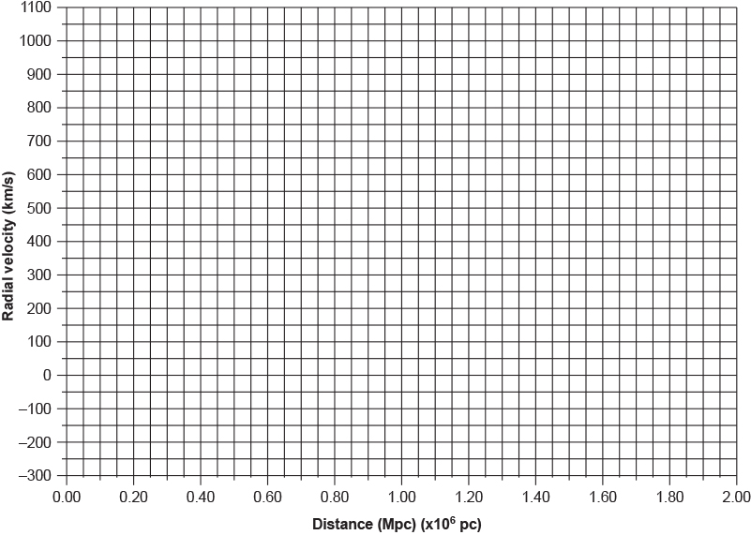

6 What does the general trend of the data suggest about what is happening in the universe? Explain your answer.

|  |
| --- |
|  |
|  |
|  |
|  |

7 Some of the radial velocities in Hubble’s data were negative. What does this tell us about their motion? Can you think of a reason why this might be so, given that the radial velocities of all of the other galaxies have positive values?

|  |
| --- |
|  |
|  |
|  |
|  |
|  |

Student worksheet

6.6 Technology aids cosmological research

Pages 150–151

Cosmological research

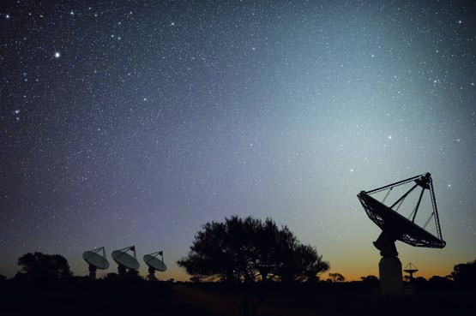

1 What is the name of the $160 million dollar project being built in Western Australia?

|  |
| --- |
|  |

2 How does a radio astronomy telescope work?

|  |
| --- |
|  |
|  |
|  |

3 What are some of the things that can be photographed with the new telescope?

|  |
| --- |
|  |
|  |

4 Consider the article ‘Australian Square Kilometre Array telescope takes shape in WA outback’ on page 150 of the Student book and answer the following questions.

a What is the article about?

|  |
| --- |
|  |
|  |

b What does the author of this text want you to understand?

|  |
| --- |
|  |
|  |
|  |

c Why do you think the author used quotes from an expert, in this case Dr Schinkel?

|  |
| --- |
|  |
|  |

Extend your understanding – what is dark matter?

Since the prediction of its existence over 40 years ago the mystery of, and ability to detect, dark matter has escaped the world's best physicsts. It is thought that these invisible particles are everywhere – constantly passing through us and the Earth – yet they provide the gravtitational pull that helps hold the galaxies together.

In the western Victorian town of Stawell, the search for dark matter is about to head underground in a gold mine.

Read the following articles and then answer the questions below:

• Bridie Smith, ‘Hunt for dark matter sends scientists underground in a Victorian goldmine’, The SydneyMorning Herald[online], 12 June 2016, <[www.smh.com.au/technology/sci-tech/scientists-hope-to-strike-gold-in-global-hunt-for-dark-matter--at-the-bottom-of-a-stawell-mine-20160609-gpf14p.html](http://www.smh.com.au/technology/sci-tech/scientists-hope-to-strike-gold-in-global-hunt-for-dark-matter--at-the-bottom-of-a-stawell-mine-20160609-gpf14p.html)>.

• Lisa Clausen, ‘Digging for dark matter’, SBS Science [online], 27 September 2016, <[www.sbs.com.au/topics/science/fundamentals/feature/digging-dark-matter](http://www.sbs.com.au/topics/science/fundamentals/feature/digging-dark-matter)>.

5 What are the hypothesised properties of dark matter, and how were these properties assumed?

|  |
| --- |
|  |
|  |
|  |

6 Why do the scientists searching for dark matter want to set up a laboratory deep underground?

|  |
| --- |
|  |
|  |
|  |

7 What are the features of the gold mine in Stawell that make it a suitable site for a dark matter laboratory?

|  |
| --- |
|  |
|  |
|  |
|  |